Classroom game-ANIMAL MIGRATIONS
Let’s follow the swallow
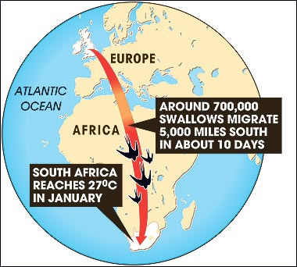
During long – distant journey to Africa and backwards, swallows, like other migrating spieces, encounter may hazards. Some of them are natural, some could be eradicated as they are man – made.
1.Discuss the problem of migrations, show the route from your country to South Africa, where swallows spend winter. Describe the route:
-starts in september, when a few swallows still have eggs in their nests – some are stolen by egg collectors
-they gather food before setting on migration – some fail because of shortage of food
in suthern Europe they encounter bird trappers – some are caught;
-also i Southern Europe they have to beware of the Eleonora’s falcon which breeds late especially so it can feed its young on migrating birds – some are caught by this predator
-the survivors set off across the Mediterranean (some don’t survive sea crossing)
-Then they face the Sahara Desert, and beyond it – the drought area of Africa, the Sahel (some are lost)
-the weather over the tropics is unpredictable (some are killed by bad weather)
-in Africa poisonous chemicals banned in Europe are still being used and affect insect – eating birds (some are killed by ‘nasty chemicals’).
THE SURVIVORS nowe reached South Africa. After spendiong the winter they must return:
-some fail to find enough food, some fail in Sahara or Sahel, the rest cross the Mditerranean, still endangered by the hunters; the weather in spring is unpredictable, especially round mountain passes; the survivors must dodge the predators and find somewhere to nest. While they were away some of the nest siteshave been destroyed.
2. Use ten A4 sized cards, these are “threat cards”, label them: 1-EGG COLLECTOR, 2-FOOD SHORTAGE, 3-SEA CROSSING, 4-PREDATOR, 5-BIRD TRAPPER, 6-DESERT, 7-DROUGHT, 8-BAD WEATHER, 9-NASTY CHEMICAL, 10-HABITAT DESTROYER.
Prepare a numbered card for each player (except for those who carry “threat cards”). Duplicate them.
3. Start the game. The children with numbered cards are the swallows. They start the game alive and standing up. If their number is called they are “killed” and have to sit down.
4. As the story of migrating swallows is told and each threat is encountered, the child with threat card pulls the appropriate number of numbered cards from the
duplicate set, and so on. The number of cards picked up will depend on the audience size. On average 20 per cent of swallows should arrive back home.

Size of audience | 20 | 30 | 40

THREAT:
Egg collector | 1 | 2 | 2
Food shortage | 1 | 1 | 1
Sea crossing | - | 1 | 1
Bird trappers | 2 | 2 | 3
Predators | 1 | 1 | 1
Sea crossing | 1 | 1 | 1
Desert | 1 | 1 | 1
Drought | 1 | 2 | 2
Bad weather | 1 | 1 | 1
Nasty chemical | 1 | 2 | 3
Food shortage | 1 | 1 | 1
Drought | - | 1 | 1
Desert | 1 | 1 | 2
Sea crossing | - | 1 | 1
Bird trappers | 1 | 2 | 3
Bad weather | 1 | 1 | 2
Sea crossing /e.g. UK/ | - | - | 1
Predator | - | 1 | 1
Habitat destroyer | 2 | 2 | 4

5.Follow-up – discuss : How many of the threats faced by migrants have been made by man? Could it be avoided? Can the participants of the game think of any others?

