GLOBAL CONVEYOR BELT - HOW DOES IT WORK?
YOU NEED:
- Ice tray
- water
- Food dyes (blue and red)
- Salt
- Dried herbs
- Flat glass
- Jar
- 2 books
- 2 candles (tea lights)
- +fan (not necessary)

- First, let’s simulate polar ice caps
- Fill in ice cube tray with fresh water, add few drops of blue food colour and mix
- Let it freeze

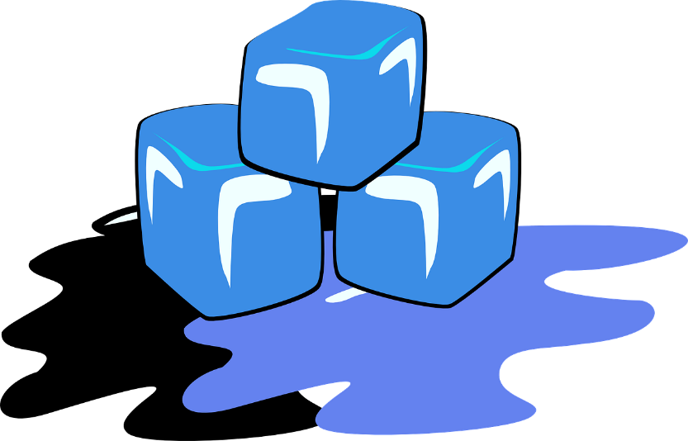

- Now, let’s create 2 ‘oceans’
- Fill in a flat, glass pan (like baking dish) with water (2/3 of volume), add 5 tablespoons of salt and few drops of RED food colour and mix.The water should be pink, but still transparent to allow observations
- Add 3 tablespoons of dried herbs (they will act as nutrients; they should sink to the bottom.
- Place a jar upside down in the middle of the dish to create 2 connected oceans

- MIXING UP
- Place baking dish on 2 books
- Add 10 blue ice cubes; place them on opposite ends of dish („north’ and ‘south’ pole)
- Light 2 tea candles and place then under the dish, on opposite ends of the jar
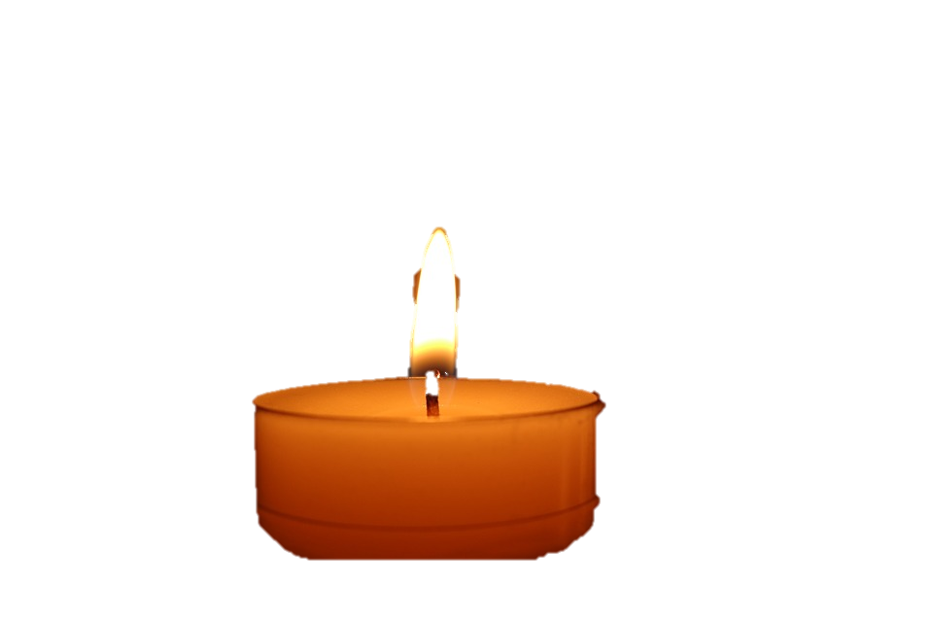

- Observations
- Draw diagrams depicting flow of the water. Pbserve the movement through the movement of the herbs and the movement of the fresh, blue water, as it mixes with and moves along the red salt water.

- Adding Surface currents
You can add fans to create wind –and Surface currents.
